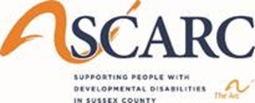
SCARC, Inc. Mandatory Visitor COVID-19 Screening Tool
The health and safety of the individuals we serve is of the utmost importance to us. Therefore, SCARC, Inc. has adopted the CDC, NJ Public Health and DDD Guidelines into our Policy and Procedures. Upon arrival to the outside of the residential program or designated visitation area, all visitors must pass this screening tool. Please answer the following:
If you have marked “Yes” to any of the above questions, entry is declined. Please vacate the premises immediately. If visitor replies “No” to all above questions, entry is allowed to the designated visitation area. Visitors must wear a mask that covers the nose and mouth at all times. Visitors entering the designated visitation area must wash their hands utilizing hand sanitizer prior to the visit. Direct contact between the individual and visitor is strictly prohibited and will be enforced. Six feet distance must be maintained at all times. If the previous rules are not followed, the visit will come to an end and the visitor will be asked to leave immediately. I must monitor and observe myself and report illness to the residential program manager immediately if I were to develop any of the above signs and symptoms within 14 days of the visit. I understand that the individual may or may not be able or willing to wear a mask which may or may not put myself, the visitor at risk.
______________________________
Visitor Name Print and Signature
_________________________
Date and Time

